Module 5 – Large Kit: Reactors and Reaction Kinetics
Chemical reactors are one of the core major units everyone thinks of when thinking about chemical engineering. But a chemical reactor can encompass a very wide range of industries: a digester for processing waste water (water industry), a blast furnace for making steel (mining), a fermenter for making beer (food industry), a bioreactor for making vaccines or pharmaceuticals (medtech), a biomass boiler (renewable energy). And many, many other examples.
In this section we will first introduce the theory for understanding reaction kinetics. Then we will introduce a few idealized concepts for reactors and build on these core assumptions to solve useful problems with reactors (for example sizing the unit from our first principles).

Outline
Primary learning outcomes for the module:
- Develop an understanding of basic definitions in reaction kinetics: elementary vs non-elementary reactions; reaction order; Arrhenius law; reactor types
- Derive solutions to a range of irreversible reaction kinetics at constant volume and temperature: zeroth order, first order and second order
- Develop an appreciation of more complicated reaction kinetics, with an understanding of how they would be solved: reversible reactions; changing order reactions; autocatalytic reactions and variable volume reactions.
- Apply simple rate equations to a range of reactors to size the units: Batch reactor, Plug flow reactor and mixed flow reactors
A useful resource is Levenspiel’s Chemical Reactor Engineering.

5.1 Recap of your pre-existing knowledge
In Chemistry pre-requisites for Fun CE, you will have already come across the concept of reaction stoichiometry. It’s founded on the law of conservation of mass: material can be transformed from one molecular to another, but the atoms themselves are not created or destroyed (this rule is not true if there are nuclear reactions).
It allows us to balance the number of molecules that will be created or consumed during a reaction, by tracking the atoms during the reaction. For example, the combustion of methane:
CH₄ + x O₂ → y CO₂ + z H₂O
x, y and z are unknown stoichiometric numbers for the combustion of 1 molecule of methane (CH₄). Following the carbon atom first, we have 1 carbon atom on the left (in the methane). So, we must have 1 carbon atom on the right. There is currently 1 carbon atom in the CO₂ so if y=1, the atoms will balance. Next looking at the water (H₂O) and following the hydrogen atoms, we have 4 hydrogens on the left-hand side and 2 hydrogen atoms in the water. So, if z = 2, the hydrogen atoms will balance. Finally following the oxygen atoms (O), there are now 2 oxygen atoms on the right-hand side (one oxygen in the water, but z=2, the stoichiometric number of the water). There are 2 oxygen atoms in the O₂ on the left and so if x=1, the equation now fully balances.
CH₄ + O₂ → CO₂ + 2 H₂O

In Material and Energy Balances you will be exposed to defined metrics which quantify overall reaction conditions. For example, for a chemical species A in a reactor, you could define the:

$$Conversion= \frac{Amountof Reactant A Consumed (in all reactions)}{Total amountof Reactant A}$$

$$Yield= \frac{Amount of desired product produced}{Maximum theoretical amount of product (all limiting reactant in desired rxn)}$$

$$Selectivity Ratio= \frac{Amount of A consumed in Rxn 1}{Amount of A consumed in Rxn 2}$$

These types of values (conversion, yield, selectivity ratio or selectivity as a percentage) are all based on the overall performance of the reactor and the reaction pathway. You can calculate the conversion of component A, if you know the amount of A in and the amount of A out. But you can’t predict the conversion of A, if you knew the reactor volume, reaction pathway and other parameters like the reactor temperature.
This module is interested in predictive calculations. We will model the reaction rate so for example, we can predict how the conversion of species A changes as a function of time (or as a function of distance through the reactor). So, we are building on the knowledge from Material and Energy Balances to get a more advanced understanding of chemical reactions.
We can already intuitively understand reaction rate, for example consider these 2 oxidation reactions: 1) burning natural gas (in a cigarette lighter) and 2) the rusting of iron. Although both involve the oxidation of a reactant (methane or iron) the reactions proceed at very different rates (or time scales). The higher reaction rate in burning the methane can create high localised temperatures (for lighting a cigarette) for a short time.
Reactions can take place in homogeneous media (single phase, consistent material, and thermodynamic properties) or heterogeneous media (multiple phases, inconsistent material, or thermodynamic properties). But in this subject, we will primarily be studying homogeneous single-phase reactions.

5.2 Manual Calculations vs Software Packages
This module is designed to teach you the basic theory of reaction kinetics and will focus on manual solutions of the rate equation. However, often the reaction kinetics may be too complicated to solve by hand (sometimes an analytical solution may not even be possible). While doing this module, you should also concurrently be learning about reaction models in HYSYS (in the tutorial classes). This module is designed in conjunction with the HYSYS module: the manual analytical solution and the iterative computational solution.

5.3 Defining Reaction Rate
Reaction rate is designed as a measure of the speed at which reactants are converted into products. So, stated in words (rather than as an equation) what do you think would be an appropriate definition of reaction rate? What units might reaction rate have?
A common initial guess is that reaction rate would be the change in number of moles of reactant per unit time (units of say moles/sec). At first, this might seem like a good definition that fits our criteria, except that number of moles is an extensive property (it depends on the total amount of reactant). So, defining reaction rate in terms of an intensive property is more convenient for us (so it is independent of total amount). Therefore, a reaction rate is usually defined as the moles of reactant consumed, per unit time and per unit volume.
$$-r_{A}=-\frac{1}{V}\left(\frac{{dN}_{A}}{dt}\right)$$
Where:
- r_{A}: Reaction rate (rate of consumption of molecule A)
- V: System volume
- N_{A}: Total moles of A
- t: time
So the units of rate are (moles of A disappearing)/(volume time) or in SI g-mole/(m³sec). Taking the volume inside the integral, you could think of the rate as the change in concentration of A as a function of time (rather than total moles). This definition only applies for a closed system so for example adding water to cordial to dilute it might reduce the concentration of the cordial, but not because it has reacted (the system is open so there is a mass transfer across the system boundary).
The negative sign is included to emphasise that the moles of A are being consumed (A is the reactant and so its concentration is dropping with respect to time).
For a given reaction stoichiometry, we can relate the reaction rate by the ratio of stoichiometric numbers. So for example, if we have a reaction stoichiometry given by:
aA + bB → eE + fF
We can say that:
$$r= -\frac{1}{a}\frac{d\left[A\right]}{dt}=-\frac{1}{b}\frac{d\left[B\right]}{dt}=\frac{1}{e}\frac{d\left[E\right]}{dt}=\frac{1}{f}\frac{d\left[F\right]}{dt}$$
Where [X] denotes the concentration of the species. Remember that stoichiometric numbers are negative for reactants and positive for products.
Worked Example 5.1
Say we have a stoichiometric equation given by:
A + 2B → 3C
- If we know the initial rate of change of A to be -2 moles/m³sec, what is the initial rate of production of component C?
- What is the initial rate of change of component B?

What parameters might affect the reaction rate? Things like: concentration of reactants (or pressure for gas phase reactions); system temperature; activation energy; and the presence of a catalyst. Perhaps we already intuitively understand from our experiences with the real world that reaction rates are likely to be a function of temperature and concentration.
Rate = f (T, C)

Stated more explicitly, a stoichiometry like:
A → product
Will usually have a rate equation form like:
$$-r_{A}=k(T)×{[A]}^{n}$$
Where:
k: A temperature dependent rate constant
[A]: Concentration of A
n: A power the concentration is raised to (or the order of the rate equation)

5.4 Elementary and non-Elementary Reactions
An elementary reaction is one in which the chemical species react directly to form the products in a single reaction step (and with a single transition state). i.e., no reaction intermediates are detected and there is no need to postulate intermediate states to describe the reaction on a molecular scale.
A non-elementary reaction has a series of intermediate reaction steps between the reactant and product, which are required to describe the reaction pathway.
In general, it is impossible to know whether a reaction is elementary or non-elementary based on the reaction stoichiometry. But if we know the reaction is elementary, we can use the stoichiometry to determine the rate equation. You can reason this through from collision theory; if 2 species need to react (A and B) then a drop in the concentration of either has a corresponding drop in the reaction rate.
So, for the elementary reaction:
A → Product
The rate equation is:
${-r}_{A}=k(T) [A]$ (Eqn 3.1)

And for the elementary reaction:
A + B → Product
The rate equation is:
$-r_{A}= -k(T) \left[A\right]\left[B\right]$ (Eqn 3.2)

For non-elemental reactions, there is no correlation between the stoichiometry and the rate equation. The reaction rate cannot be known without a reaction model or experimental data.
So, for example for the reaction:
H₂ + Br₂ → 2HBr
The rate equation is:
$-r_{HBr}= \frac{k_{1}(T)\left[H_{2}\right]{[{Br}_{2}]}^{\frac{1}{2}}}{k_{2}(T)+\frac{[HBr]}{[{Br}_{2}]}}$ (Eqn 3.3)
So, it does not correlate to the reaction stoichiometry. You can reason this though because the reaction pathway from reactants to products is a stepwise reaction with several reaction intermediates. One of these steps may be the rate limiting step in the reaction pathway and so the overall reaction rate may be harder to predict.

5.5 Order of a reaction
Reaction rates often have a form like:
$$-r_{A}=k{[A]}^{m}{[B]}^{n}$$
The exponents in the reaction rate equation (m and n) are called the reaction orders. We can refer to the order of the reaction (meaning the overall order = m + n) or we can refer to the order of a species within the reaction (for example the order of reactant A is m). In elementary reactions, the reaction order of each chemical species equals the stoichiometric number. So, in equation 3.1, 3.2 and 3.3 above, the reaction orders would be: first order; second order and 1.5 order respectively.

5.6 Temperature dependence: Arrhenius Law
So far, we have written the rate constant, k(T), only as a function of temperature in each rate equation. The temperature dependence of the rate constant is modelled by the Arrhenius Law:
$$k\left(T\right)= k_{0}e^{\left(\frac{{-E}_{a}}{RT}\right)}$$
Where:
- k(T): Rate constant
- k₀: frequency factor (sometimes called the pre-factor constant and sometimes written as A)
- E_{a}: Activation Energy
- R: Universal Gas Constant (8.314 J/K mol)
- T: Temperature
The logic of the Arrhenius law is that the molecular bonds are held within activation energy wells (E_{a}). If the thermal energy (kT) is sufficient to overcome this activation energy, the reaction can proceed to a new lower energy state. As the bonds vibrate with some fixed thermal energy (at all temperatures above 0K) there is always a finite possibility of the reaction proceeding, but as macroscopic scale we perceive this as happening at a lower rate.

Taking the natural log of both sides of the rate constant we can show that:
$$\ln\left(k\right)=\ln\left(k_{0}\right)- \frac{E_{a}}{RT}$$
k₀, E_{a} and R are all constants. So another way of presenting the relationship is to plot ln (k) against 1/T:
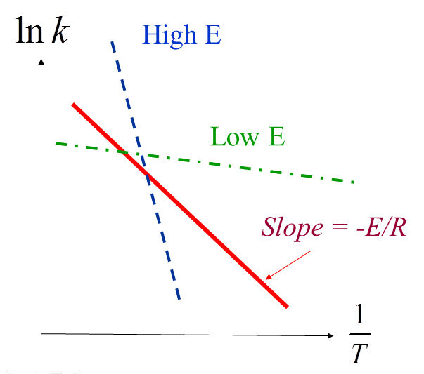
Looking at this graph emphasises a number of important conclusions:
- For higher activation energies, the rate constant is more sensitive to T
- A given reaction is more sensitive to T at low temperatures
- The pre-factor constant (k₀) does not affect the reaction rate’s sensitivity to T
- For a given reaction, changes in the activation energy indicate a change in the reaction mechanism

5.7 Reactor Design
Once we know the reaction kinetics (the form of the rate equation) we can begin to design a reactor. What parameters might affect the design of the reactor? Temperature certainly (as we know it affects the rate). But this is something we will probably try to control after the reactor is built (for example by changing a flowrate of cooling water). What parameters might affect the physical design: things like the reactor volume (which changes the residence time for a given flowrate); the type of reactor; the method of operation of the reactor.
Types of reactors can include:
- Batch Reactor: Material is feed into the reactor; the reaction begins and after a predetermined time period the reaction ends and products are removed. A simple example would be baking a cake; all the ingredients are put into a pan, then the pan is loaded into the oven until the reaction is complete and the cake is removed. Advantages of batch reactors are that they’re typically simple and so don’t need a lot of supporting equipment. In industry, they’re commonly used when small amounts of material are to be treated.
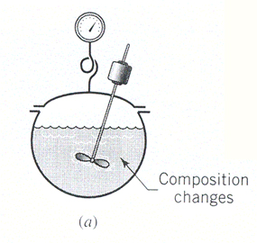

- Steady State Flow: Material passes through the reactor continuously, so product is continually produced (rather than being produced in batches). Unlike the batch reactor, these reactors operate at steady state. An example would be the catalytic converter in cars: the exhaust gases from the engine often have large concentrations of nitrous oxides (NO_{x}) which can contribute to smog in a city and environmental pollution. The catalytic converter uses carbon monoxide to reduce the nitrous oxides to N₂ and CO₂ which are less environmentally harmful. Once the engine is running, it releases exhaust gases continuously (it is not practical to release the gases in batches) and so the catalytic converter operates continuously, to remove the more harmful gases from the exhaust.
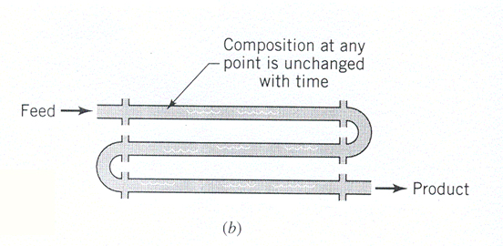

- Semi-batch / Unsteady State Flow:
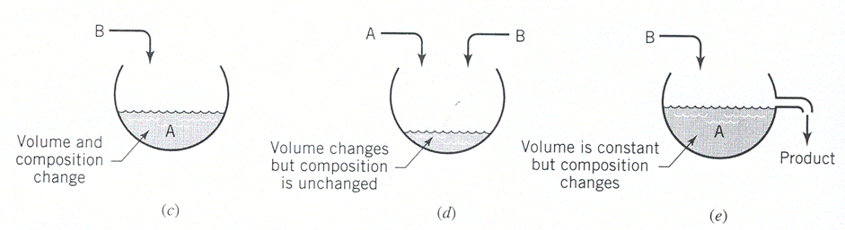

Like a batch process, except that it allows for the addition of reactant over time. Batch and semi-batch reactors tend to have smaller upfront capital costs to build and install but larger operating costs than a steady state flow reactor. This makes them economically preferable for small scale processes. But their cost effectiveness drops off as the production capacity scales up: there are non-productive periods during change over or when switching blades; the material handling costs (filling, emptying, cleaning) scale up at a higher rate for batch and semi-batch processes.

5.8 Solving Reaction Rates
In this section we will look at a range of different rate equations and derive solutions to track how the concentration (or conversion) of a reactant species will change as a function of time.
From Material and Energy Balances, you should be familiar with the mass balance equation with a reaction taking place. For a given volume unit in a reactor, operating at steady state, we can write a mass balance as:
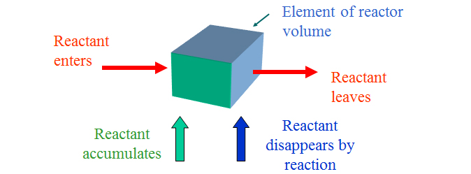
Rate of reactant flow in | = | Rate of reactant flow out | + | Rate of reactant loss  ?? | + | Rate of reactant accumulation
We want to solve the rate of reactant loss (i.e., the rate of reactant consumption). In M&EB you have only looked at this as an overall figure (total conversion or selectivity) but here we will determine the rate and can hence calculate the conversion as a function of time.
In a constant volume system, the reaction rate is related to the change in number of moles of reactant:
$$r_{i} = \frac{dC_{i}}{dt} = \frac{1}{V}\left[\frac{dn_{i}}{dt}\right]$$
Where r_{i} is the rate of reaction of component i.
- C_{i} is the concentration of i at a given time
- t is time
- V is volume of the system
- n_{i} is the number of moles of i in the system
This relationship can be quite powerful. For example, if we substitute in the ideal gas law equation of state, we can say:
$$PV=nRT \\ r_{i}= \frac{dC_{i}}{dt} = \frac{1}{V}\left[\frac{dn_{i}}{dt}\right] \\ = \frac{1}{RT}\left[\frac{{dP}_{i}}{dt}\right]$$
In a gas system, pressure exerted by one component (the partial pressure) is usually used in place of concentration, which would be used to describe a liquid.
Rather than writing the rate in terms of concentration or partial pressure, we can also write it in terms of the conversion of A (X_{A}).
The conversion of A is given by:
$$X_{A }= \frac{N_{A0}- N_{A}}{N_{A0}} = 1-\frac{N_{A}}{N_{A0}} = 1-\frac{C_{A}}{C_{A0}} \\ C_{A}=C_{A0}\left(1-X_{A}\right) \\ dC_{A}= -C_{A0}dX_{A}$$
For a reactant A, we can write the rate equation in a generalised way:
$$r_{A}= k\left(T\right)f(C)$$
Where k(T) follows the Arrhenius Law and f(C) depends on the order of the reaction for an elementary reaction.

To begin we will look at the simplest solution case and so we will assume the reactor is operating at steady state, so there is no accumulation term. Secondly, we will consider an isothermal reactor; although the reaction may be exothermic or endothermic, we will assume there is sufficiently good temperature control (a cooling or heating jacket around the reactor) that it maintains the temperature constant. This is important because the rate constant is a function of temperature (following the Arrhenius law) and would complicate our solution if temperature was also a function of time.
For an isothermal system (k is a constant) we can now write:
$$r_{A}= \frac{dC_{A}}{dt} = k f\left(C\right) \\ \frac{dC_{A}}{f(C)} =k dt \\ \int_{C_{A0}}^{C_{A}}{\frac{dC_{A}}{f(C)} =kt}$$
Where C_{A0} is the concentration at time t = 0.

5.8.1 Irreversible Reactions

Irreversible Unimolecular First Order Reactions
To solve we would need to know the functional form of f(C). For elementary reactions, this functional form is often quite simple, but it can be extremely complex for non-elementary reactions. Consider an irreversible, unimolecular 1st order reaction (elementary).
For a unimolecular reaction (only one reactant reacting with itself), the reaction stoichiometry is:
A → product
For a first order reaction, the rate is linearly proportional to the concentration of reactant, so the rate equation can be expressed as:
$$f\left(C\right)= {C_{A}}^{1}$$
So, the rate equation for an isothermal (k is constant) 1st order unimolecular reaction is:$$- r_{A}= - \frac{{dC}_{A}}{dt}=k C_{A}$$
$$-\ln\left(\frac{C_{A}}{C_{A0}}\right)=kt \\ -\ln\left(1- X_{A}\right)=kt$$
Worked Example 5.2
A liquid decomposes by first order reaction kinetics. 50% of A is converted to product in 15 mins. How long would it take to reach 75% conversion?

Zeroth Order Irreversible Reactions
A zero-order reaction implies the rate equation is independent of concentration of any reaction species.
$$-r_{A}= -\frac{dC_{A}}{dt}=k$$
Integrating and observing that C_{A} can never be negative gives:
C_{A0} – C_{A} = C_{A0} X_{A} = k t for t < C_{A0} / k

Irreversible Bimolecular Elementary Second Order Reactions
For a bimolecular (two reactant molecules) that’s second order and elementary (the order of each reacting species is the stoichiometric number in the reaction) we might expect a reaction like:
A + B → Product

It’s an elementary reaction and hence we know the rate equation:
$$-r_{A}=k C_{A}C_{B}$$

Although the initial amount of A and B may not be the same (C_{A0} is not necessarily equal to C_{B0}) we do know that based on the reaction stoichiometry, the rate at which A is consumed must be the same as the rate at which B is consumed. So, we can also write:
$$-r_{A}=k C_{A}C_{B}= -r_{B}$$

As with the first order reaction before, we can write this in terms of the conversion of A and B (X):
$${-r}_{A}=k C_{A0} \left(1- X_{A}\right) C_{B0}\left(1- X_{B}\right)$$

As the amount of A consumed is the same as the amount of B consumed, we can also write and then substitute in:
$$C_{A0} X_{A}= C_{B0} X_{B} \\ X_{B}= \frac{C_{A0}}{C_{B0}} X_{A}$$
So
$${-r}_{A}=k C_{A0} \left(1- X_{A}\right) C_{B0}\left(1- \frac{C_{A0}}{C_{B0}}X_{A}\right)$$

We will let the ratio of (C_{B0} / C_{A0}) be a constant M, So C_{B0} = M C_{A0}. So
$${-r}_{A}=k C_{A0} \left(1- X_{A}\right) \left(C_{B0}- C_{A0} X_{A}\right) \\ = k C_{A0} \left(1- X_{A}\right) \left({M C}_{A0}- C_{A0} X_{A}\right) \\ =k C_{A0}^{2} \left(1- X_{A}\right) \left(M- X_{A}\right)$$
$$- r_{A}= C_{A0}\frac{dX_{A}}{dt} =k C_{A0}^{2} \left(1- X_{A}\right) \left(M- X_{A}\right) \\ \int_{0}^{X_{A}}{\frac{{dX}_{A}}{\left(1-X_{A}\right)\left(M- X_{A}\right)} = k C_{A0}\int_{0}^{t}{dt}}$$

Now how do we solve the left-hand side of this integral? We can use a partial fraction method to rearrange this into a form that can be integrated.
$$\frac{1}{\left(1- X_{A}\right) \left(M- X_{A}\right)}= \frac{A}{\left(1- X_{A}\right)}+ \frac{B}{\left(M- X_{A}\right)}$$

Where:
$$A \left(M- X_{A}\right)+B\left(1- X_{A}\right)=1$$

To solve for A and B, we can take the 2 limits. When X_{A} = 1:
$$A \left(M- X_{A}\right)=1 \\ A= \frac{1}{\left(M- 1\right)}$$

When X_{A} = M:
$$B \left(1- X_{A}\right)=1 \\ B= \frac{1}{\left(1-M\right)}= \frac{-1}{(M-1)}$$

Substituting back into the integral, we can now solve:
$$\int_{0}^{X_{A}}{\frac{{dX}_{A}}{\left(1-X_{A}\right)\left(M- X_{A}\right)} = k C_{A0}\int_{0}^{t}{dt}}$$
$$\frac{1}{M-1}\int_{0}^{X_{A}}{\frac{1}{1-X_{A}}{dX}_{A} + \frac{-1}{M-1}\int_{0}^{X_{A}}{\frac{1}{\left(M- X_{A}\right)}{dX}_{A}}= k C_{A0}\int_{0}^{t}{dt}} \\ \frac{1}{M-1}\left[-\ln\left(1- X_{A}\right)+\ln\left(M- X_{A}\right)-\ln\left(M\right)\right]½_{0}^{X_{A}}=k C_{A0} t \\ \frac{1}{M-1}\ln\left(\frac{M- X_{A}}{M \left(1- X_{A}\right)}\right)=k C_{A0} t$$

This holds providing that M ≠ 1 (which would require a different integral solution). Rearranging into a final more convenient form, we could check this relationship against real experimental data.
$$k C_{A0} (M-1) t =\ln\left(\frac{M- X_{A}}{M \left(1- X_{A}\right)}\right)$$

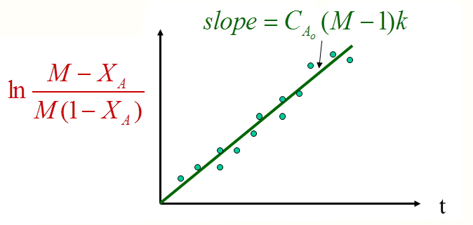

Worked Example 5.3
In the above solution, we have assumed M ≠ 1. When C_{A0} = C_{B0} and so M = 1, show that the conversion as a function of time can be represented as:
$$\frac{X_{A}}{1- X_{A}}=k C_{A0} t$$
You will need to go back to the initial assumptions of the previous derivation and follow this logic through again for the new condition.

Worked Example 5.4
Hydrogen iodide breaks down very slowly to hydrogen and iodine.
2 HI → H₂ + I₂
The rate equation for the decomposition is second order, so given as:
-r_{HI} = k [HI]²
At 25 ºC the rate constant is 2.4 x 10⁻¹¹ L/mol s. If 1 mol of gaseous HI is placed in a 1 L container, determine the time until 20% of it has decomposed.

Irreversible Bimolecular Non-Elementary Second Order Reactions
One important thing to be aware of is that the stoichiometry does not always match the rate equation (as in non-elementary reactions). For example, a reaction with the stoichiometry
A + 2B → Products

Can still be second order and hence have the rate equation:
$$-r_{A}=- \frac{dC_{A}}{dt}=k C_{A} C_{B}=k C_{A0}^{2} \left(1-X_{A}\right)(M-2 X_{A})$$

The solution to this rate equation will not be the same as the elementary second order reaction (in the previous section). In fact, completing the integral we can show that
$$\ln\left(\frac{M-2X_{A}}{M (1- X_{A})}\right)= C_{A0}\left(M-2\right) k t M ≠2$$

If M does equal 2 (ie the reactants A and B are initially mixed in their stoichiometric ratio) then we can derive a new solution to the rate equation (you should try this for yourself):
A + 2B → Products
$$-r_{A}=- \frac{dC_{A}}{dt}=k C_{A} 2C_{A}=2 k C_{A}^{2} \\ \frac{dC_{A}}{C_{A}^{2}}=2 k dt \\ \frac{1}{C_{A}}- \frac{1}{C_{A0}}= \frac{1}{C_{A0}} \frac{X_{A}}{1- X_{A}}=2 k t$$

Other forms of the rate equation for irreversible trimolecular reactions
As we go to higher overall reaction order, there are an increasing number of potential solutions to the reaction rate. For example, for an elementary trimolecular reaction, the original stoichiometry could be:
A + B + D → Product
A + 2B → Product
3A → Product

For A + 2B → Product
$$-r_{A}=kC_{A}C_{B}^{2}$$
$$\frac{\left(C_{A0}-C_{B0}\right)\left(C_{B0}-C_{B}\right)}{C_{B0}C_{B}}+\ln{\frac{C_{A0}C_{B}}{C_{A}C_{B0}}= {\left(C_{A0}- C_{B0}\right)}^{2} k t}$$

For 3A → Product
$${-r}_{A}=kC_{A}^{3}$$
$$\frac{1}{C_{A}^{2}}- \frac{1}{C_{A0}^{2}}=k t$$
If you want practice solving these types of problems, you can complete all these derivations, but they’re stretch exercises beyond the scope of the course.
I would strongly recommend you try to understand the steps required to solve the rate equations, rather than trying to memorize the solutions. Because of all the solutions we’ve just derived, there are also reactions that can be 3rd order and non-elementary. Given that this stoichiometry can become increasingly variant for higher order reactions, it becomes necessary to be able to derive solutions (rather than trying to memorize all potential solutions) if we intend to solve the rate equation by hand calculation.

Empirically Determined Rate Equations of n^{th} Order
Often the rate equation may not be known a priori. In this case we would need to determine the rate equation empirically.
For a rate equation:
$$-r_{A}= -\frac{dC_{A}}{dt}=k C_{A}^{n}$$
$C_{A0}^{1-n}- C_{A}^{1-n}=\left(n-1\right) k t$ $n ≠1$
To determine n (the reaction order) this relationship may then be checked against real data by trial and error, by curve fitting or graphically:
ln (-r_{A}) = ln (k) + n ln (C_{A})

A List of Solutions for Irreversible Reactions
We’ve included a list of solutions to kinetic equations below. But a word of caution: Know how to do these derivations, but it is not worth trying to memorize these (We would not usually ask memory questions in an exam: We are trying to test your understanding not your memory).
Order | Stoichiometry | Rate Equation | Solution To Rate Equation
Zero | Any | $$-r_{A}=k$$ | C_{A0} – C_{A} = C_{A0} X_{A} = k t
1st | A → Prod | $$- r_{A}=k C_{A}$$ | $$-\ln\left(1- X_{A}\right)=k t$$
2nd | A + B → Prod | $$-r_{A}=k C_{A}C_{B}$$ | $$\frac{X_{A}}{1- X_{A}}=k C_{A0} t M=1$$  $$k C_{A0} \left(M-1\right)t =\ln\left(\frac{M- X_{A}}{M \left(1- X_{A}\right)}\right) M ¹ 1$$
2nd | 2A→ Prod | $$-r_{A}=k C_{A}^{2}$$ | $$C_{A}^{-1}- C_{A0}^{-1}=k t$$
2nd | A + 2B → Prod | $$-r_{A}=k C_{A} C_{B}$$ | $$\frac{1}{C_{A}}- \frac{1}{C_{A0}}= \frac{1}{C_{A0}} \frac{X_{A}}{1- X_{A}}=2 k t M=2$$  $$\ln\left(\frac{M-2X_{A}}{M (1- X_{A})}\right)= C_{A0}\left(M-2\right) k t M ≠2$$
3rd | A + B + D → Prod | $$-r_{A}=k C_{A} C_{B} C_{D}$$ | $$\frac{1}{\left(C_{Ao}- C_{B0}\right)\left(C_{Ao}- C_{D0}\right)}\ln\left(\frac{C_{A0}}{C_{A}}\right)+ \frac{1}{\left(C_{Bo}- C_{D0}\right)\left(C_{Bo}- C_{A0}\right)}\ln\left(\frac{C_{B0}}{C_{B}}\right)+ \frac{1}{\left(C_{Do}- C_{A0}\right)\left(C_{Do}- C_{B0}\right)}\ln\left(\frac{C_{D0}}{C_{D}}\right)=k t$$
3rd | A + 2B → Prod | $$-r_{A}=kC_{A}C_{B}^{2}$$ | $$\frac{\left(2C_{A0}-C_{B0}\right)\left(C_{B0}-C_{B}\right)}{C_{B0}C_{B}}+\ln{\frac{C_{A0}C_{B}}{C_{A}C_{B0}}= {\left({2C}_{A0}- C_{B0}\right)}^{2} k t}$$
3rd | 3A → Prod | $${-r}_{A}=kC_{A}^{3}$$ | $$\frac{1}{C_{A}^{2}}- \frac{1}{C_{A0}^{2}}=2k t$$

5.8.2 Reversible Reactions
So far, we have only investigated irreversible reactions (the reaction only proceeds in a single direction). But for many reactions, it is more appropriate to conceive of an equilibrium reached between the reactants and products; the reactants can react to form products, but also the products can react to produce reactants. We can frame this mathematically, like the irreversible reactions we have just looked at, with a forward rate constant and a reverse rate constant.
$A \begin{matrix}\underset{→}{k_{1}} \\ \overset{←}{k_{2}}\end{matrix} R$
It’s important to note that a reversible reaction is a distinct concept from a reversible thermodynamic process (discussed in a future module).
The ratio of forward and reverse rate constants is usually defined as the equilibrium constant (K_{C}) so that:
$$K_{C}= \frac{k_{1}}{k_{2}}$$

For the stoichiometry above, we can make several statements about the relationship between the rate of consumption of A and the rate of production of R.
$$\frac{{dC}_{R}}{dt}= - \frac{{dC}_{A}}{dt}= C_{A0}\frac{dX_{A}}{dt}$$
If the forward and reverse reactions are both first order with respect to the species A and R respectively, then the rate equation can further be written as:
$$\frac{{dC}_{R}}{dt}= - \frac{{dC}_{A}}{dt}= C_{A0}\frac{dX_{A}}{dt}= k_{1}{ C}_{A}- k_{2}{ C}_{R}$$
You would then be able to solve this as you have for irreversible reactions. We have included a sample solution below, but this is at the limit of your expected knowledge for the course.

Solving Reversible Reaction Example
If we define M as C_{R0} / C_{A0} and recognising that the amount of A consumed (C_{A0} X_{A}) equals the amount of R produced, we can further write the rate equation as:
$$\frac{{dC}_{R}}{dt}={ C_{A0}\frac{dX_{A}}{dt}= k}_{1}\left(C_{A0}- C_{A0}X_{A}\right)- k_{2}\left(C_{A0}M+ C_{A0}X_{A}\right) \\ { \frac{dX_{A}}{dt}= k}_{1}\left(1- X_{A}\right)- k_{2}\left(M+ X_{A}\right)$$
At equilibrium, the rate of change of reactants or products has come to zero. So:
$${ \frac{dX_{A}}{dt}= 0 = k}_{1}\left(1- X_{Ae}\right)- k_{2}\left(M+ X_{Ae}\right) \\ \frac{k_{1}}{k_{2}}= K_{C}= \frac{M+ X_{Ae}}{1- X_{Ae}}$$
Or we can write the relationship between k₁ and k₂ as:$$k_{2}= \frac{1- X_{Ae}}{M+ X_{Ae}} k_{1}$$Substituting this back into the rate equation, we can write:
$${ \frac{dX_{A}}{dt}= k}_{1}\left(1- X_{A}\right)- \frac{1- X_{Ae}}{M+ X_{Ae}}k_{1}\left(M+ X_{A}\right)$$

With a few lines of algebra, this reduces to:
$$\frac{dX_{A}}{dt}= \frac{k_{1}\left(M+1\right)}{M+ X_{Ae}}\left[X_{Ae}- X_{A}\right]$$
So we can solve the integral in a fairly straight forward way.
$$\int_{0}^{X_{A}}{\frac{1}{X_{Ae}-X_{A}}{dX}_{A}= \int_{0}^{t}{\frac{k_{1}\left(M+1\right)}{M+ X_{Ae}}} dt} \\ -\ln\left(X_{Ae}- X_{A}\right)+\ln\left(X_{Ae}\right)= \frac{k_{1}\left(M+1\right)}{M+ X_{Ae}} t \\ -\ln\left(\frac{X_{Ae}- X_{A}}{X_{Ae}}\right)= \frac{k_{1}\left(M+1\right)}{M+ X_{Ae}} t \\ -\ln\left(1- \frac{X_{A}}{X_{Ae}}\right)= \frac{k_{1}\left(M+1\right)}{M+ X_{Ae}} t$$

Worked Example 5.5
A first order reversible reaction takes place in a batch reactor.
$$A \begin{matrix}\underset{→}{k_{1}} \\ \overset{←}{k_{2}}\end{matrix} R$$
Initially there is 0.5 mol/L of A and no R. After 8 minutes, the conversion of A is 33.3% while the equilibrium conversion is 66.7%. Find the rate constants and then the rate equation for this reaction.

5.8.3 Reactions of Changing Order
Sometimes the reaction rate behaves differently at different concentration limits. So, modelling these real reaction kinetics means allowing for the reaction order to change as a function of concentration. For example, consider the irreversible reaction:
A → R
Imagine the reaction behaves as first order at low concentrations of A but becomes zeroth order at high concentrations of A; if the concentration of A is sufficiently high, the reaction rate becomes limited by another factor, such as the number of unoccupied reacting sites on the surface of a catalyst.
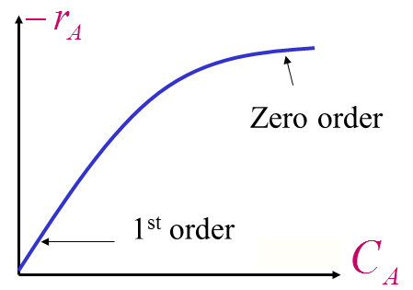
How might we model a reaction rate like this?
1. We can use a functional form of the rate equation like:
$$-r_{A}= - \frac{dC_{A}}{dt}= \frac{k_{1}C_{A}}{1+ k_{2}C_{A}}$$
k1 and k2 don’t refer forward and reverse rate constants here, instead they represent 2 separate constants in the forward rate equation. As we have done in all other example, we can solve this form of the rate equation to give the concentration profile (or conversion) as a function of time.
$$\int_{C_{A0}}^{C_{A}}{\frac{1+ k_{2}C_{A}}{k_{1}C_{A}}}{dC}_{A}=- t \\ \ln\left(\frac{C_{A0}}{C_{A}}\right)+ k_{2}{(C}_{A0}- C_{A})=k_{1} t$$

2. We could consider 2 different parallel pathways of different order, occurring simultaneously but where one dominates in a certain limit.
Path 1: -(r_{A})₁ = k₁ Zero Order
Path 2: -(r_{A})₂ = k₂ C_{A} First Order
Overall: (-r_{A})_{overall} = k₁ + k₂ C_{A}
Note that this solution will be a kind of inverse of point 1 above (which was first order for low concentrations of A and zero order for high concentrations of A). Solution 2 is first order for high concentrations of A and zero order for lower concentration. So, it doesn’t apply to the previous graph.

5.8.4 Autocatalytic Reactions
Autocatalytic means one of the products functions as a catalyst for the forward reaction. So as more product is produced, the reaction can proceed faster.
A + R → R + R
How might we express the rate equation and then a solution to the rate equation?
$$-r_{A}= - \frac{dC_{A}}{dt}=k C_{A}C_{R}$$

5.8.5 HYSYS Simulation of Reaction Kinetics
Until now, we’ve only considered isothermal processes in the solutions we’ve derived here (so k was a constant). We’ve also only considered solutions for a batch reactor, not a mixed reactor. We’ve also only considered relatively simple rate equations. For example, the stoichiometry to produce methanol from carbon monoxide and hydrogen via a solid catalyst has the stoichiometry:
CO + 2H₂ → CH₃OH
But its rate equation is given by in [Kiler et al. (1981)]:

The reaction is a heterogeneous catalytic reaction, meaning that a catalyst is used to accelerate the reaction, but active sites on the surface of the catalyst can be blocked by the adsorption of reactant or product molecules, slowing the reaction rate. For this reason, there is a denominator term in the rate equation (that represents a slowing of the reaction rate). In the numerator, we can see there are forward and reverse rate constants.
This reaction rate would be tremendously difficult to solve by hand to generate a concentration profile (as we have previously done in this module). For this reason, we simultaneously teach you how to create simulations in HYSYS. Simple rate equations can be solved by hand (and you get a better understanding for what they mean) but more complicated rate equations (as above) are typically solved numerically using software packages.
There are a range of software packages available to investigate reaction rates (for example Aspen HYSYS, Comsol, Matlab) but as Aspen HYSYS is commonly used in industry and is quite user friendly, it’s what we focus on in CPA. But hopefully you can see how the workshop modules on HYSYS are complimentary to what we’re covering in lectures.

5.9 Design of Single Ideal Reactors

5.9.1 Batch Reactor
The simplest kind of reactor is a Batch Reactor:
- Feed enters the reactor (i.e., the reactor is charged), it mixes and reacts to form product over a certain period, and a mixture of feed and product exists the reactor (i.e., the reactor is discharged).
- The composition changes over time, therefore this system is unsteady state
- But we can still assume that the composition is spatially uniform
An example of a batch reactor is simply baking a cake, where all the ingredients fed into the reactor and mixed, then the reactor (the cake tin) is heated to the correct temperature (the oven providing the heat), and then the product is removed and consumed.

5.9.2 Plug Flow Reactor
The next type of ideal reactor we’ll look at is a Plug Flow Reactor:
- Also called slug flow, piston flow, ideal tubular, or unmixed flow reactor
- In this course, we’ll call them Plug Flow Reactors (PFR), due to the fluid flow pattern inside the reactor: plug flow, which means no back-mixing. An element of fluid flows straight through the reactor.
- This system is steady-state which means it does not vary over time, but the composition does change along the length of the reactor.
- For the assumption of plug flow to be valid, the residence time for all fluid elements must be constant i.e., all fluid spends the same amount of time inside the reactor

An interesting example of a Plug Flow Reactor is the growth of algae for biofuel and biodiesel production. The algae is grown in long clear tubes called Photobioreactors, allowing light into the reactor for the algae: Algae Photobioreactor.

5.9.3 Mixed Flow Reactor
The last ideal reactor we will examine is a Mixed Flow Reactor:
- Also known as mixed reactor, back mix reactor, ideal stirred tank reactor, C-Star, Continuously Stirred Tank Reactor or Constant Flow Stirred Tank Reactor
- In this reactor, all elements of fluid are well-mixed and are uniform in space, and the composition of the exiting fluid is the same composition as the fluid in the reactor
- Because the system is steady-state, the system does not change over time
- In comparison to a PFR, the flow pattern of the MFR is mixed
Mixed Flow Reactors are often used in the traditional chemical industry to react two liquids in homogenous liquid-phase flow, but they can also be used in the biochemical industry as bioreactors, where oxygen and temperature can be easily manipulated to keep microorganisms alive.
Most real reactors are a combination of ideal reactors/ on a spectrum of ideal reactors. In this module, we’ll look at designing ideal reactors, and then we’ll move onto real reactors in later modules and subjects.

5.9.4 Sizing a Batch Reactor
To analyse the performance of a reactor, we use performance or design equations; performance equations are a way of comparing reactors and working out if our designs are reasonable). To derive these equations, we can take a mass balance over the reactor. We can use the whole reactor because composition is assumed to be constant throughout the whole volume.
Starting with our basic mass balance over the reactor:
Input= output + disappearance by reaction + accumulation
However, we know nothing enters or leaves the system boundary during operating in a batch reactor; we only have loss and accumulation due to chemical reactions
$$Rate of loss of A through reaction=-(rate of accumulation of A within reactor)$$
$$Disappearance=rate ×volume=\frac{moles}{time ×volume}×volume=\left(-r_{A}\right)∙V$$
$$accumulation= \frac{dN_{A}}{dt}$$
$$N_{A}=N_{A0}\left(1-X_{A}\right)∴\frac{dN_{A}}{dt}=\frac{d\left[N_{A0}(1-X_{A})\right]}{dt}=-N_{A0}\frac{dX_{A}}{dt}$$
Where N_{A0} is a constant, as the initial number of moles of A in the system
Disappearance of A= - Accumulation of A, so
$$\left({-r}_{A}\right)∙V=-\left(-N_{A0}\frac{dX_{A}}{dt}\right)$$
After separation of variables and integration:
$$dt∙\left({-r}_{A}\right)V=N_{A0}dX_{A}$$
$$\int_{0}^{t}{dt}=N_{A0}\int_{0}^{X_{A}}{\frac{{dX}_{A}}{\left(-r_{A}\right)∙V}}$$
$$t=N_{A0}\int_{0}^{X_{A}}{\frac{{dX}_{A}}{\left(-r_{A}\right)∙V}}$$
This is the time is takes to achieve the desired conversion given a specific rate and volume. This is the design equation for a batch reactor.
Here is a YouTube Video explaining the derivation.
The volume of this batch reactor, as discussed in the previous module, can be constant or variable. If the density of the fluid remains constant, then so will the volume, which means we can use the constant volume version (i.e,. assuming there is no expansion ε_{A}=0 ∴ Δρ=0)

5.9.5 Sizing a Steady State Mixed Flow Reactors
To find the design equation of the mixed flow reactor, we’ll start with a mass balance over the system:
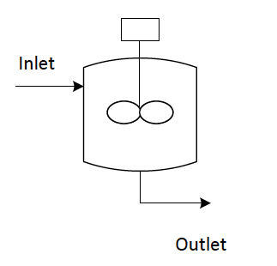
Input= output + disappearance by reaction + accumulation
Here we have written the rate as disappearance of A. The rate (r_{A}) refers to the rate of change of A; a positive rate would mean A is being produced and a negative rate would mean A is being consumed. So rate of disappearance by reaction = -r_{A}. So note that you could also write input = output –production of A + accumulation and you would end up for the same final formula.
Rate of disappearance = - r_{A} (negative rate of production)
If the system is operating at steady state there is no accumulation.
Assuming a simple reaction of A → B: A is being consumed but not produced.
$$Input=F_{A0}\left(1-X_{A0}\right)=F_{A0} { X}_{A0}=0$$
$$Output=F_{A}=F_{A0}(1-X_{A})$$
$$Disappearance=\left({-r}_{A}\right)∙V=\frac{-moles of A being produced}{time × volume}×volume$$

Substitute these terms into the mass balance:
$$F_{A0}=F_{A0}\left(1-X_{A}\right)+\left({-r}_{A}\right)∙V$$
$$F_{A0}=F_{A0}-F_{A0}X_{A}+\left({-r}_{A}\right)∙V$$
$$F_{A0}X_{A}=\left({-r}_{A}\right)∙V$$
$$\frac{V}{F_{A0}}=\frac{X_{A}}{\left({-r}_{A}\right)}$$

Re-arrange this expression to find space time:
$$\frac{V}{F_{A0}}=\frac{τ}{C_{A0}}=\frac{X_{A}}{\left({-r}_{A}\right)}$$
$$τ=\frac{1}{s}=\frac{V}{ν_{0}}=\frac{VC_{A0}}{F_{A0}}=\frac{C_{A0}X_{A}}{\left({-r}_{A}\right)}$$
Note that we have used τ for the time not t (as we did for the batch reactor). This is to emphasise that they’re not really the same: in a batch reactor all atoms are ‘cooked’ for the exact same period. In continuous flow reactors (MFR and CSTR) this time represents a mean residence time in the reactor, but each atom can be present for different total lengths. The term τ is also sometimes referred to as a space time.
Here are 2 YouTube videos explaining the derivation: 1 and 2 above.
Note: In these equations, we’re assuming all the feed is fresh, not partially converted feed. The inclusion of partially converted feed will be discussed in a later module on Recycle Reactors.
In these design equations, we have 4 variables of interest: X_{A}, -r_{A}, V, F_{A0} ∴ we can find 1 from the other 3. We often try to find V, to have the smallest reactor possible, or find F_{A0} to see how much feed our system can handle.

If we plot this relationship, we can find the size of the reactor using the conversion directly, rather than calculating it. Using the following graph (Mixed flow reactor rate conversion curve):
The area of the reciprocal rate curve will give you V/F_{A0}, allowing you to easily find the volume.
If constant density is assumed, the following expression is true:
$$X_{A}=1-\frac{C_{A}}{C_{A0}}$$
This expression allows us to write out the design equations in terms of concentration rather than conversion:
$$τ=\frac{V}{ν}=\frac{C_{A0}X_{A}}{\left({-r}_{A}\right)}=\frac{C_{A0}-C_{A}}{\left({-r}_{A}\right)}=\left(\frac{1}{{-r}_{A}}\right)\left(C_{A0}-C_{A}\right)$$
We can also find the volume from the concentration version of the Levenspiel graph, taking the rectangular area beneath the curve between the inlet and outlet conditions.
Notice that these expressions have rate in them: we can find the design equation based on the kind of reaction present in the system.

Worked Example 5.6
Liquid phase reaction, A → R, the rate of reaction is as follows:
C_{A} (mol/L) | 0.1 | 0.2 | 0.3 | 0.4 | 0.5 | 0.6
-r_{A}(mol/L∙ min) | 0.1 | 0.3 | 0.5 | 0.6 | 0.5 | 0.25

What size Mixed Flow Reactor is needed with X_{A}=0.75, F_{A0}=1000 mol/hr, at C_{A0}=1.2 mol/L.
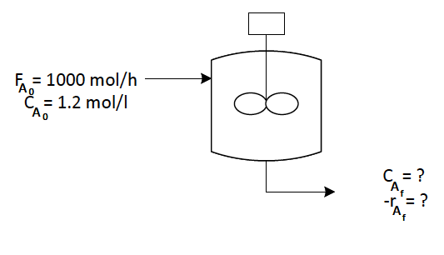

5.9.6 Sizing a Steady State Plug Flow Reactor
As before, we’ll start with a mass balance over the system. Unlike with mixed flow, the composition does change along the reactor length: therefore, we need a differential across an element of volume: dV
$$Input=output+disappearance+accumulation$$
As before, there is no accumulation, as A the system is steady state.
$$Input= F_{A}$$
$$Output= F_{A}+dF_{A}$$
$$dF_{A}=d\left(F_{A0}\left(1-X_{A}\right)\right)=d\left(F_{A0}-F_{A0}X_{A}\right)={-F}_{A0}dX_{A}$$
$$Disappearance=\left({-r}_{A}\right)∙dV=\frac{moles of A reacting}{time × volume}×volume$$
$$F_{A}=F_{A}-F_{A0}dX_{A}+\left({-r}_{A}\right)∙dV$$
$$F_{A0}dX_{A}=\left({-r}_{A}\right)∙dV$$

The differential means this only represents a slice of the reactor volume. To calculate conversion across the whole reactor, we need to complete the integral across the whole length.
$$\int_{0}^{V}{\frac{dV}{F_{A0}}}=\int_{0}^{X_{Af}}{\frac{dX_{A}}{{-r}_{A}}}$$
$$\frac{V}{F_{A0}}=\frac{τ}{C_{A0}}=\int_{0}^{X_{Af}}{\frac{dX_{A}}{{-r}_{A}}}$$

Can re-arrange:
$$τ=\frac{V}{ν_{0}}=\frac{VC_{A0}}{F_{A0}}=C_{A0}\int_{0}^{X_{Af}}{\frac{dX_{A}}{{-r}_{A}}}$$

Here is a YouTube video explaining the derivation:
We can use this design equation to find our reactor volume given how much feed it is given, and the conversion required.
Again, we assume fresh feed ∴ X_{Ai}=0. If feed is partially converted, X_{Ai} can be substituted for the lower integral limit. This will be discussed further in later modules.
If the system has constant density:
$$X_{A}=1-\frac{C_{A}}{C_{A0}}$$
$$dX_{A}=-\frac{dC_{A}}{C_{A0}}$$
We can use this expression to convert the design equation once again to be in terms of concentration rather than conversion.
$$\frac{V}{F_{A0}}=\frac{τ}{C_{A0}}=\int_{0}^{X_{Af}}{\frac{dX_{A}}{{-r}_{A}}}=\frac{-1}{C_{A0}}\int_{C_{A0}}^{C_{Af}}{\frac{dC_{A}}{{-r}_{A}}}=\frac{1}{C_{A0}}\int_{C_{Af}}^{C_{A0}}{\frac{dC_{A}}{{-r}_{A}}}$$
$$τ=\frac{V}{ν_{0}}=C_{A0}\int_{0}^{X_{Af}}{\frac{dX_{A}}{{-r}_{A}}}=-\int_{C_{A0}}^{C_{Af}}{\frac{dC_{A}}{{-r}_{A}}}=\int_{C_{Af}}^{C_{A0}}{\frac{dC_{A}}{{-r}_{A}}}$$
We can solve these equations in plug flow for all sorts of kinetics. Some are very complicated and require numerical integration- we use computers, especially programs like HYSYS for that. For some simple kinetics, we can easily derive the equations.
 | Conversion |  | Concentration
Batch | $t=N_{A0}\int_{0}^{X_{A}}{\frac{{dX}_{A}}{V∙\left(-r_{A}\right)}}$  ε_{A} ≠ 0 | $$t=C_{A0}\int_{0}^{X_{A}}{\frac{{dX}_{A}}{\left(-r_{A}\right)}}$$ε_{A} = 0 | $$t=\int_{C_{A}}^{C_{A0}}{\frac{dC_{A}}{\left(-r_{A}\right)}}$$  ε_{A} = 0
Mixed Flow | $$\frac{V}{F_{A0}}=\frac{τ}{C_{A0}}=\frac{X_{A}}{\left({-r}_{A}\right)}$$ |  | $$τ=\frac{C_{A0}-C_{A}}{({-r}_{A})}$$
Plug Flow | $$\frac{V}{F_{A0}}=\frac{τ}{C_{A0}}=\int_{0}^{X_{Af}}{\frac{dX_{A}}{{-r}_{A}}}$$ |  | $$τ=\int_{C_{A}}^{C_{A0}}{\frac{dC_{A}}{{-r}_{A}}}$$

Worked Example 5.7
Molecule A reacts to form R irreversibly:
A → R
The reaction is elementary. Will a CSTR or PFR have a smaller volume for the same inlet conditions and conversion?
CSTR: $τ=\frac{VC_{A0}}{F_{A0}}= \frac{V}{v_{0}}=\frac{C_{A0}- C_{A}}{\left({-r}_{A}\right)}$
PFR: $τ=\frac{V}{ν_{0}}=C_{A0}\int_{0}^{X_{Af}}{\frac{dX_{A}}{{-r}_{A}}}=-\int_{C_{A0}}^{C_{Af}}{\frac{dC_{A}}{{-r}_{A}}}=\int_{C_{Af}}^{C_{A0}}{\frac{dC_{A}}{{-r}_{A}}}$
1. Write the reaction kinetics
2. Plot reaction rate (y-axis) vs concentration (x-axis)
3. Plot -1/r_{A} (y-axis) vs C_{A} (x-axis)
4. Draw areas on the -1/r_{A} vs C_{A} plot to represent PFR and CSTR space time
5. From the areas in Qu 4 which reactor configuration will be larger?
6. Provide a brief physical explanation for which reactor you would expect to have a larger final volume.

Zero Order Plug Flow
A → R
$${-r}_{A}=k$$
$$\frac{τ}{C_{A0}}=\frac{V}{F_{A0}}=\int_{0}^{X_{Af}}{\frac{dX_{A}}{{-r}_{A}}}=\int_{0}^{X_{Af}}{\frac{dX_{A}}{k}}=\frac{X_{A}}{k}$$
$$kτ=k\frac{C_{A0}V}{F_{A0}}=C_{A0}X_{A}$$

First Order Irreversible Plug Flow
A →R
$$C_{A}=\frac{N_{A}}{V}=\frac{N_{A0}\left(1-X_{A}\right)}{V_{0}\left(1+ε_{A}X_{A}\right)}=C_{A0}\frac{1-X_{A}}{1+ε_{A}X_{A}}$$
$${-r}_{A}=k∙C_{A}=k∙C_{A0}\frac{1-X_{A}}{1+ε_{A}X_{A}}$$
$$\frac{V}{F_{A0}}=\frac{τ }{C_{A0}}=\int_{0}^{X_{A}}{\frac{dX_{A}}{{-r}_{A}}}=\int_{0}^{X_{A}}{\frac{dX_{A}}{k∙C_{A0}\frac{1-X_{A}}{1+ε_{A}X_{A}}}}$$
$$\frac{τ∙k∙C_{A0}}{C_{A0}}=\int_{0}^{X_{A}}{\frac{dX_{A}}{\frac{1-X_{A}}{1+ε_{A}X_{A}}}}$$
$$k∙τ=\int_{0}^{X_{A}}{\left[\frac{1+ε_{A}X_{A}}{1-X_{A}}\right]dX_{A}}$$
$$k∙τ=\int_{0}^{X_{A}}{\left[\frac{1}{1-X_{A}}+\frac{ε_{A}(X_{A}-1)}{1-X_{A}}+\frac{ε_{A}}{1-X_{A}}\right]dX_{A}}$$
Then integrate:
$$kτ=-\ln\left(1-X_{A}\right)-ε_{A}X_{A}-ε_{A}\ln\left(1-X_{A}\right)$$
$$kτ=-\left(1+ε_{A}\right)\ln\left(1-X_{A}\right)-ε_{A}X_{A}$$

5.10 Design for Single Reactors
Processing fluids is very important in chemical engineering; so engineers have come up with lots of ways to process fluids, there are different:
- Kinds of reactors: batch or flow
- Configurations: series or recycle
- Augmentations: inter-stage heating/ cooling and feed ratios etc.

This means that designing a scheme to process fluids is a bit of a puzzle- there are no exact formulae to follow, but there’s lots of factors to consider and you have to use your pre-existing knowledge.
Some of the important factors to consider:
- Reaction type
- Scale
- Cost
- Occupational Health and Safety

Whichever system is selected, design will influence the economics of the project:
- Size of the units: this is the most important economical impact
- Ratio of products: we won’t look at this because we are only looking at single-reaction systems. This will be discussed further in later subjects

5.10.1 Comparison of Single Reactors

Batch Reactor vs Plug Flow Reactor
Batch reactors have both advantages and disadvantages to be aware of:
Advantages | Disadvantages
Small capital cost | High operating cost
Flexibility of operation | Time for cleaning and shutdown
Sterility | Poorer quality of product

This is why small batches of lots of products are recommended for batch reactors, rather than large batches. This is also why batch reactors are used in the food and pharmaceutical industries, where flexibility and sterility are very important.
We can compare the Design Equations of Batch Reactors and Plug Flow Reactors:
If ε_{A}=0:
Plug: $t=C_{A0}\int_{0}^{X_{A}}{\frac{{dX}_{A}}{(-r_{A})}}$
Batch: $t=C_{A0}\int_{0}^{X_{A}}{\frac{{dX}_{A}}{(-r_{A})}}$

They’re the same design equation i.e. an element of fluid stays inside for the same amount of time. But this conclusion does not hold if density changes in the system.

Mixed Flow Reactors vs Plug Flow Reactors: A Graphical Comparisons
We can graphically compare the volume required of a reactor on a graph called a Levenspiel plot. This is also called a rate-concentration, rate-conversion curve or reciprocal rate curve. These are very useful graphs and we’ll use them throughout the next few modules.
Here is a YouTube video to explain the concept.

These graphs are based on our design equations:
MFR:
This shows that we can find the volume or space time by finding the rectangular area of the graph, using the inlet and outlet conditions.
Here are YouTube video explaining the concept with an example.

PFR:
This shows that we can find the volume or space time by finding the integral area under the curve, using the inlet and outlet conditions.
This is why the PFR volume is always less (for n^{th} order reaction): there is no wasted volume.
Here are YouTube videos explaining the concept with an example: 1, 2, 3 and 4.
Fixed values on dimensionless reaction rate groups can be plotted as lines on a graph, which makes it easy to compare systems and impacts of kinetics on our system:
Order | Dimensionless Group
1st | kτ
2nd | kτC_{A0}

Overall, we know that conversion is affected by many factors, including; order, system, expansion, kinetics, volume ratios ∴
$$X_{A}=f\left(n, ε_{A}, kτ, \frac{V_{m}}{V_{p}}\right)$$

Worked Example 5.8
A homogenous gas reaction A → 3R has a reported rate (at 215°C) of:
$${-r}_{A}={10}^{-2}C_{A}^{\frac{1}{2}} \left[\frac{mol}{L∙s}\right]$$
Find the space time needed for 80% conversion of a 50% A and 50% inert feed to a plug flow reactor, operating at 215°Cand 5 atm. Note: C_{A0}=0.0625 mol/L.

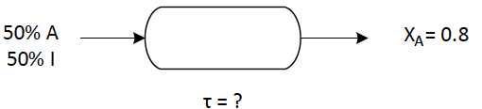

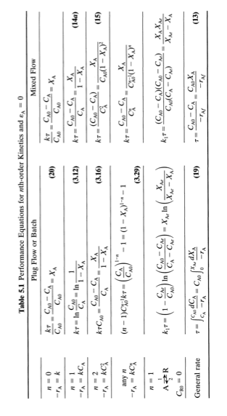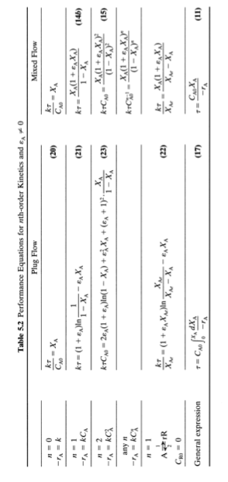

Module 5 Summary

Key Points:
- Reaction Kinetics
  - Reaction rates
  - Elementary vs. Non-elementary
  - Order
  - Temperature dependence (Arrhenius)
- Reactor Design
  - Flow: Steady State, Batch, Semi-Steady State
  - Irreversible and Reversible reactions
  - Ideal reactors (Batch, Plug Flow Reactor, Mixed Flow Reactor)
  - Sizing
  - Comparison

Key Skills:
- Solve irreversible and reversible reaction kinetic problems (0th, 1st, 2nd order kinetics)
- Size and compare Batch Reactors, Plug Flow Reactors, and Mixed Flow Reactors with above kinetic expressions

